Three Part Cards
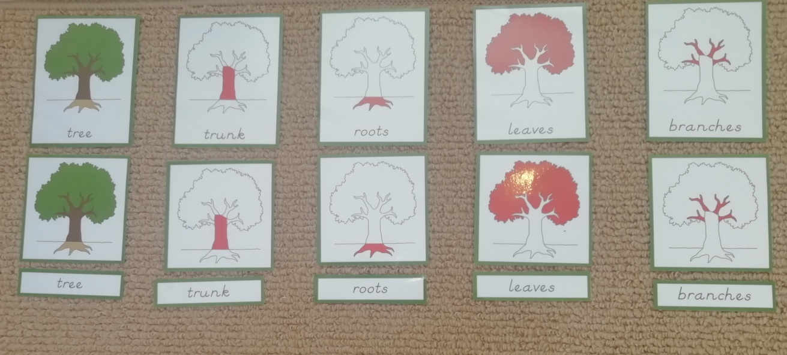

Three part cards are from the culture curriculum area and are used in Botany and Zoology as part of a 4 part series of activities that introduce a child to a subject matter. They are the fourth activity in the series (1 – The Real Experience, 2 – The Parts Puzzles, 3 – The Pairing Cards, 4 – The Three Part Cards). Activities 2, 3 and 4 are included on this resources page.

Three part cards are used to break down a subject matter and name the component parts of, for example, a tree, a flower, a fish etc. The three parts are as shown in the picture below.
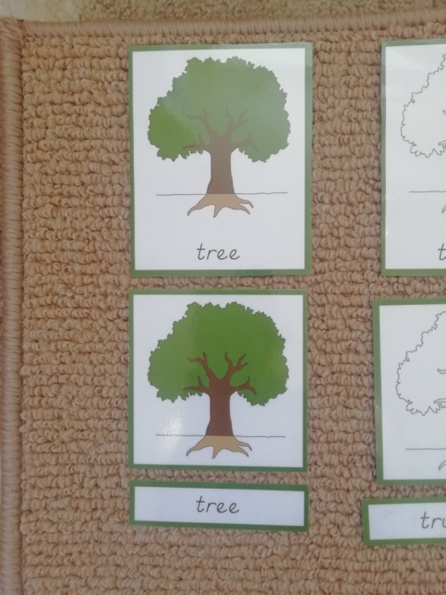

One card containing both a picture and a label is visually matched to two separate cards, one showing the picture, the other the part name.

Your child does not need to be able to read to do this activity. Young children of 2 or 3 can just visually match the pictures. Older children who can either read or know some letters can read the words and match or look for beginning letters etc. Some children who cannot yet read and do not know any letters will still be able to visually match the words.
- As with the pairing cards the first set of cards (the single cards with picture and name) should be laid out across the mat from left to right.
- The second set of cards (the picture only) should be put into a pile face down on the mat underneath the top row of cards.
- Allow your child to turn the pile over one card at a time and match to the top row of cards. Name the parts of the tree as you turn each card over.
- Place the name label cards in a face down pile at the bottom of the mat and allow your child to turn them over one at a time and place with the corresponding picture.
- As with all activities demonstrate first what your child needs to do with one or two cards. So turn one card over, very obviously compare it to the first set of cards until you find a match and then place that card below the first card.
- If your child has already performed the pairing cards activity they will understand quickly what to do here.
- The first time you do this activity just give the names of the parts of the tree. Once your child has grasped the concept you can talk more and give more information. For example when you turn over the roots cards, talk about roots and what they do etc.
- If you are able to it is great to do this activity in the garden where you can see a real tree. Then you can look at the actual parts of a real tree as you name them. Let your child touch them and describe them, collect parts and make a tree collage etc.

